Installing OPENCV and Required Python Libraries
1. in Windows OS, make sure your PC/Laptop are installed with Python version 3.xx.x
2. Open Command Prompt or Terminal.
3. Verify Python installation:
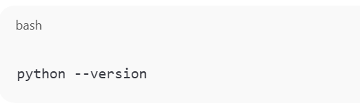
4. Install required libraries:
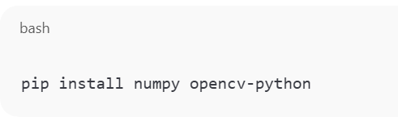
5. Verify installation by importing the libraries in Python by Type python or python3 and press
Enter to start the interactive interpreter.
6. At the >>> prompt, type the following lines and press Enter after each:
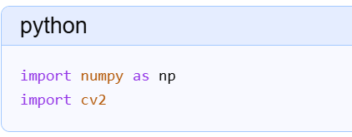
7. If no error messages appear, the imports were successful. You can then print the installed versions to confirm:
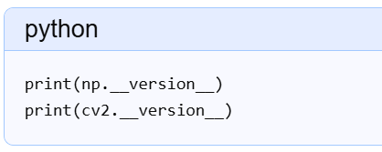
8. To exit the interpreter, type exit() and press Enter.

